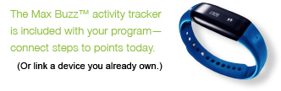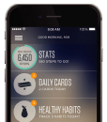[](http://ahealthymerewards.com/learnmore)­­­

This reward may be considered taxable income. Consult your tax advisor.

*Program is available to Blue Cross Blue Shield of Massachusetts subscribers only.

Whether you’re a couch potato, a fitness guru, or somewhere in between, a**healthy**me Rewards makes it easy to earn up to $400 in rewards annually, just for making   
healthier choices.* Blue Cross Blue Shield of Massachusetts is partnering with   
Virgin Pulse®´´, an independent company, to bring you this online wellness program.   
Start tracking your extra steps and get rewarded for hitting your goals.