Introducing ahealthyme®’ Rewards

Dear <Firstname>,

I’m pleased to announce that, in partnership with Blue Cross Blue Shield of Massachusetts, <COMPANY NAME> is offering you a new way to improve your health and well-being.

ahealthyme Rewards is a wellness program that financially rewards you for making healthy choices every day.

The program is digitally-based, which means you can access the tools, inspiration, and guidance you need to achieve your individual goals, right from your smartphone or computer. You’ll receive an activity tracker included with your program to measure your progress and
keep track of the points you’ve earned—or you can sync up your own personal device with
an easy-to-use app. By year’s end, you could earn up to $400, just for hitting easy goals.*

I hope you’ll give it a try. I think you’ll find that ahealthyme Rewards is fun, fulfilling, and designed to help you succeed. You can earn points by managing your stress; eating a healthy diet; or ramping up your physical activity through fitness challenges with co-workers.

There’s no cost to you and it’s easy to get up and running. The program will be launching in our workplace soon, so stay tuned for information on how to register for your ahealthyme Rewards account.

Sincerely,

<Leadership signature>

<Firstname> <Lastname>

*Program is available to Blue Cross Blue Shield of Massachusetts subscribers only.

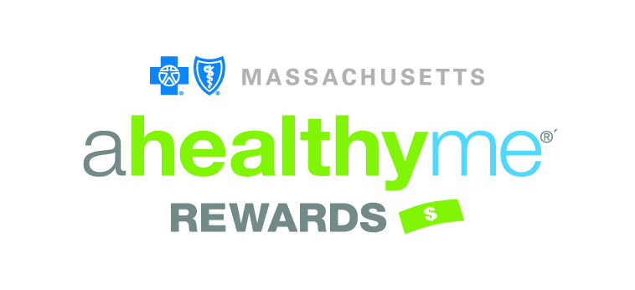
Blue Cross Blue Shield of Massachusetts is an Independent Licensee of the Blue Cross and Blue Shield Association. ® Registered Marks of the Blue Cross and Blue Shield Association. ®´ Registered Marks of Blue Cross and Blue Shield of Massachusetts, Inc., and Blue Cross and Blue Shield of Massachusetts HMO, Inc. © 2018 Blue Cross and Blue Shield of Massachusetts, Inc., and Blue Cross and Blue Shield of Massachusetts HMO Blue, Inc. 18-BLU-059 (09/18) 190268M 55-2090

