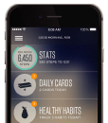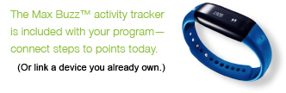[](http://ahealthymerewards.com/learnmore)­­­

*Program is available to Blue Cross Blue Shield of Massachusetts subscribers only.

Blue Cross Blue Shield of Massachusetts is partnering with Virgin Pulse®´´, an independent company, to bring you a**healthy**me Rewards. Simply join in, link your  
 included Max Buzz™ activity tracker, and make healthier choices every day—like   
taking the stairs or getting some extra sleep at night. Track your healthy activities in the Virgin Pulse® app, so you can hit your goals and rake in the rewards.*